**Steps to Use Your Own Machine to Host Web( YELP example)**

10/17/2015, Dingchao Zhang

1. If your machine does not have xampp installed,please download and install xampp package for your operating system at here : <https://www.apachefriends.org/index.html>

Here is an Youtube walking though xampp installation for windows 8 and windows 8.1:

<https://www.youtube.com/watch?v=U5ghHLRv6uc>

1. Start apache server, if you see the following error about server shuts down unexpectedly, do the following steps in 2, otherwise skip this part and directly go to step 3.

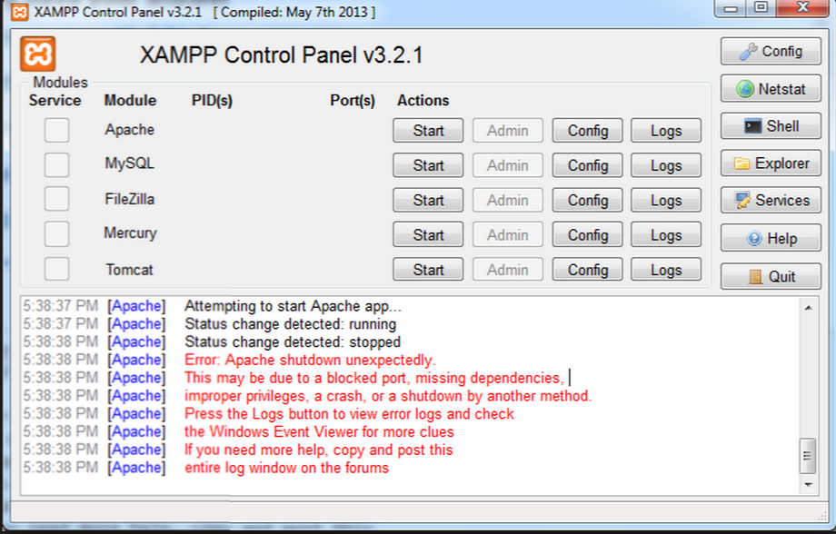

2.1 Please click Config button, open httpd.conf file

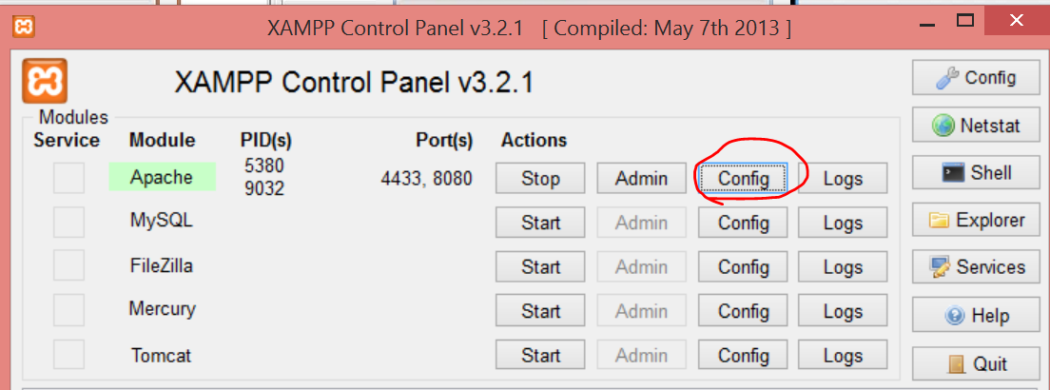

2.2 Modify all the places where it writes the port ID 80 to 8080 in httpd.conf

2.2.1 Specifically modify the Listen to specific IP addresses to 8080:

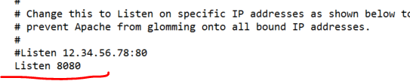

2.2.2 And specifically modify the ServerName Localhost to 8080

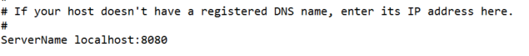

* + 1. Save the changes to httpd.conf

2.3 Please click Config button, open httpd-ssl.conf file

2.3.1 Modify all the places where it writes the port ID 443 to 4433 in httpd-ssl.conf

2.3.2 Specifically ensure to modify the Listen to specific HTTPs port to 4343:

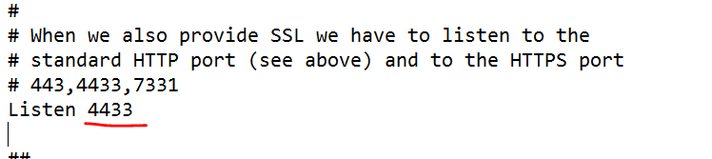

* + 1. Specifically ensure to modify the virtua host and servername port to 4343:

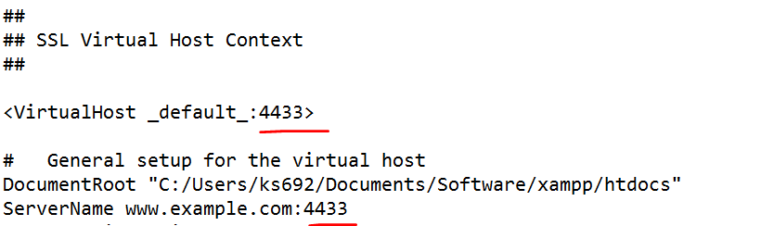

* 1. Save the changes to httpd-ssl.conf
  2. After all the above changes are saved, restart xampp, and start Apache server, and you shall see it is running at ports 4433 and 8080

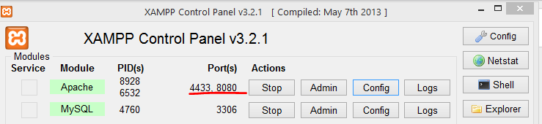

1. Please click Config button, open httpd-xampp.conf : comment out Require local , and add “Order deny, allow”, and “Allow from all “or Allow from ( certain IP addresses) before ErrorDocument 403 in the buttom of the file, which should be looking like the following:

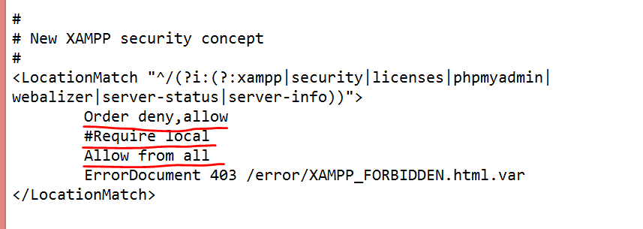

1. Click Explorer in XAMPP menu, create a short cut of htdocs to desktop 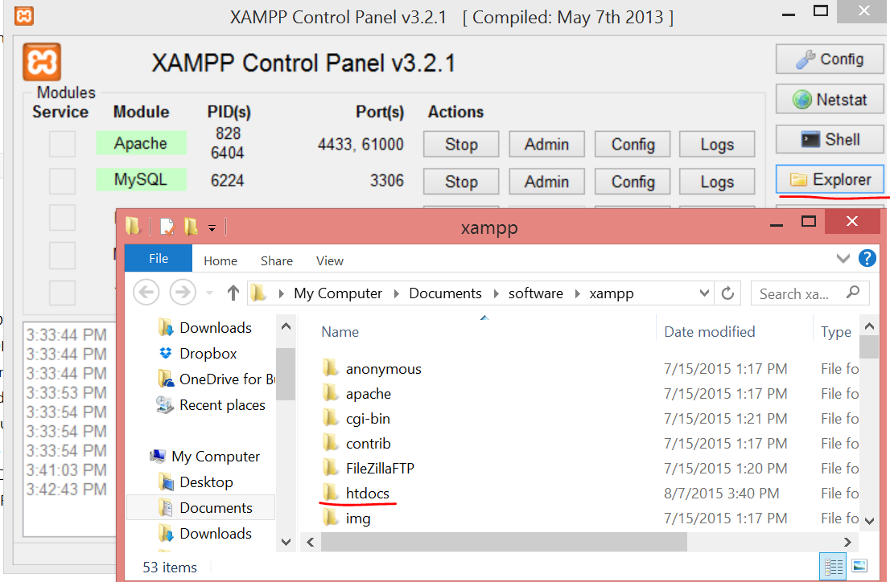
2. Download the whole folder from <https://github.com/dingchaoz/AuthenticFoodSpotter>, name that folder as yelp-shared-hosting, and save it in the xampp/htdocs directory

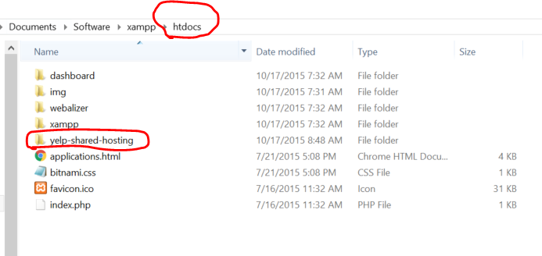

1. Please click Config button, open httpd.conf file, change the DocumentRoot and Directory to the yelp-shared-hosting path

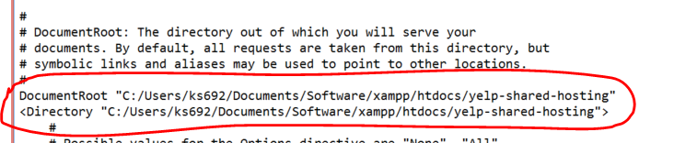

1. Please click Config button, open httpd-ssl.conf file, change the DocumentRoot to the yelp-shared-hosting path

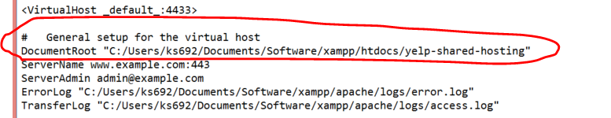

1. Open localhost:8080/phpmyadmin in browser, create a new database called “yelp” by clicking New in the left database menu.

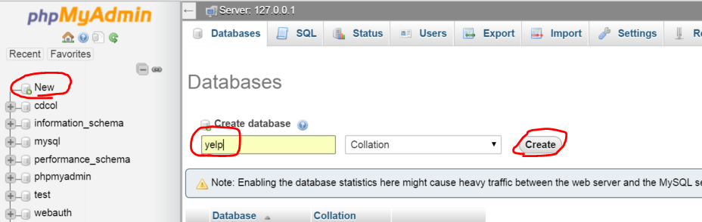

1. Click to open newly created yelp database in the left, click SQL tab and copy the cotent of yelp.sql resided in Elp Doc folder within yelp-shared-hosting folder in to the SQL run window.

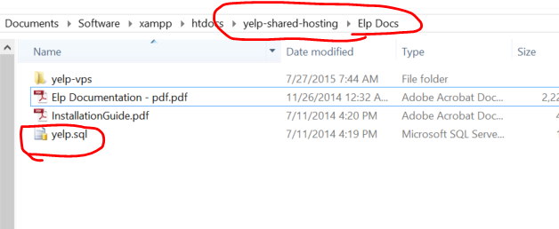

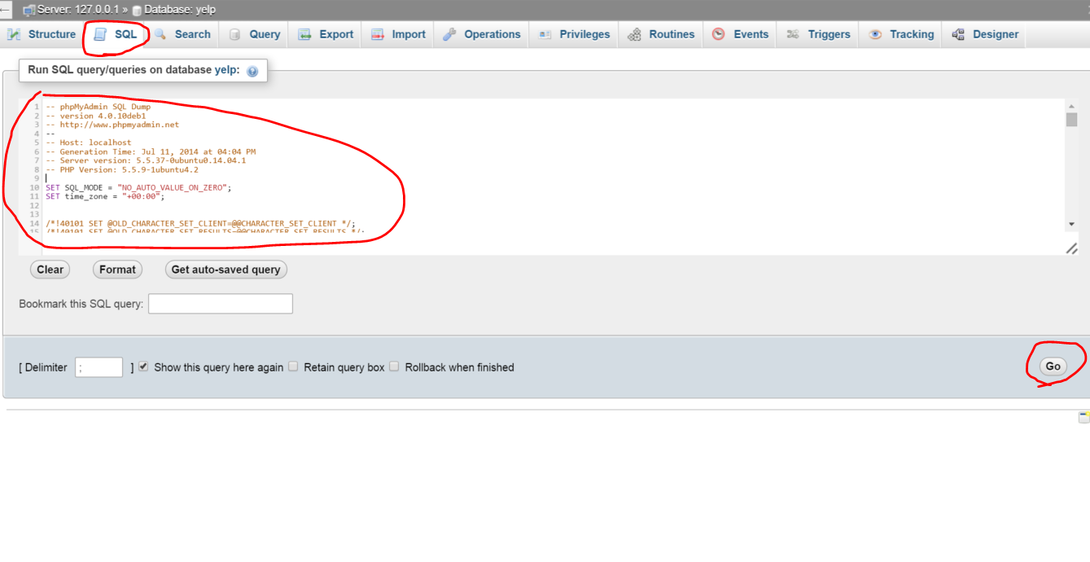

1. Follow the Elp Documentation – pdf to edit related php files in app/config folder

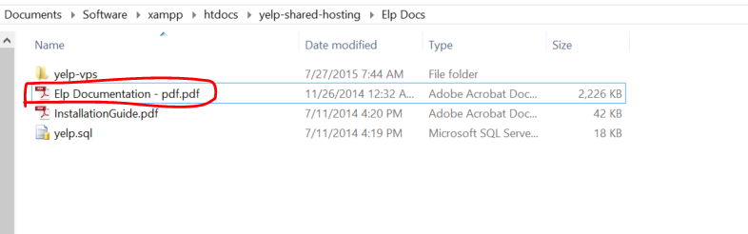

1. Now go to localhost:8080 in web browser, you shall see a Yelp cloned web:

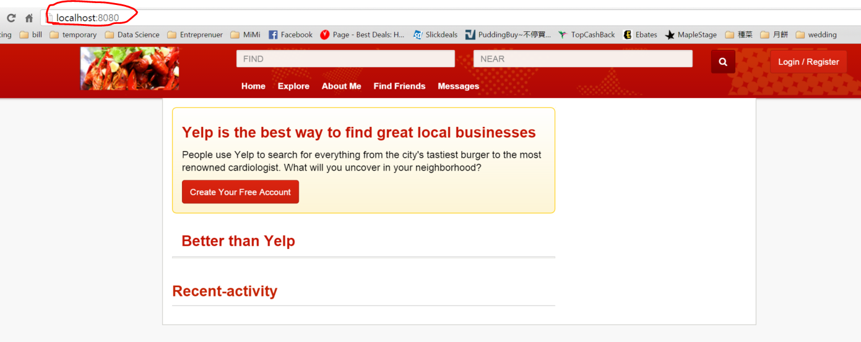

1. User registration( Need to troubleshoot):

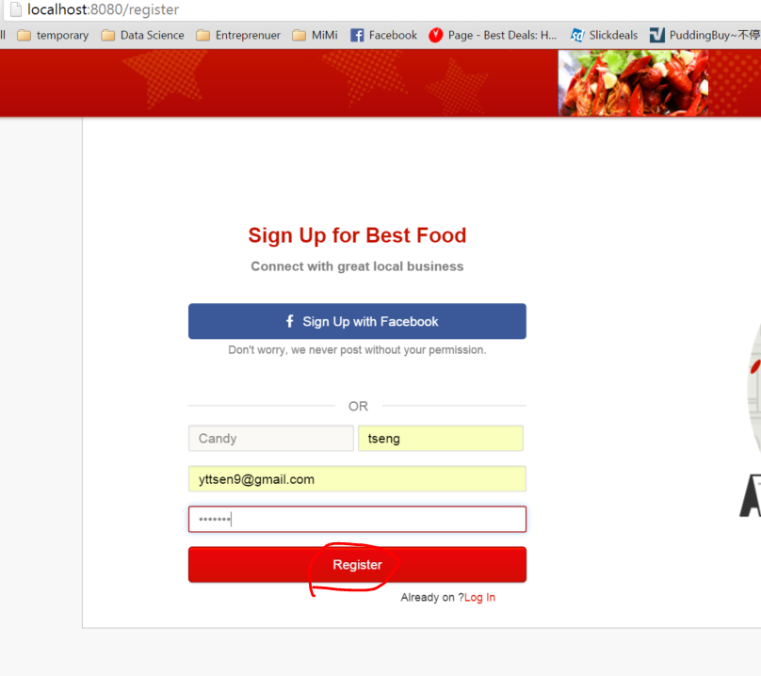

It is supposed to send out an email to the registered email address and ask for activation, but the auto mail function is not configured right yet( Elp Documentation app/config/services.php mandrill api key not setup), for now we have to manually activate user in database, change the activated from 0 to 1:

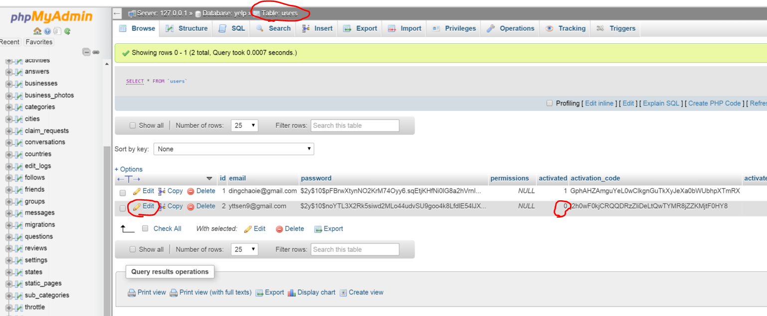

1. Admin registration( Need to troubleshoot):

Refer to Elp Documentation page 3 : go to localhost:8080/admin/install.

1. Open the Command Prompt window by clicking Windows key + R at the same time,

type ***cmd*** in Run window:

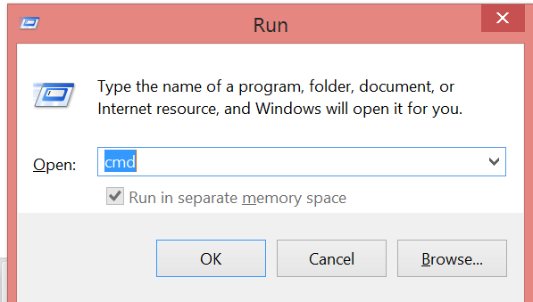

Type ipcofig in windows command line window and look for Ipv4 Address under Wireless LAN if you are using wifi

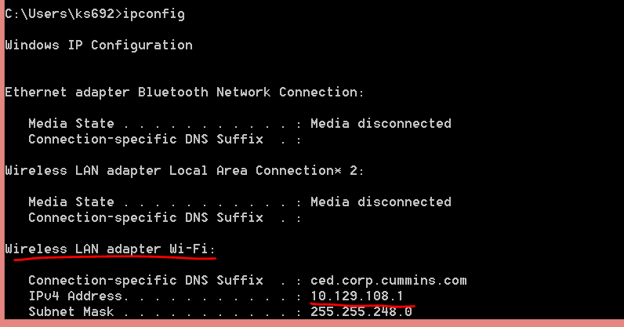

**Note** that if you switch from wifi to wired connection, or move your machine from one location to another( building to building, office to home, etc) , your Ipv4 address might get changed.

1. You can share http://yourIPv4address:61000 addres with people who are in the same Local Area Network, and they should see the same page as you see.

You may click the stop button to shut down the hosting.

1. To Enable sharing the web to people outside your Local Area Network, we need to configure the router in your house. You can google ” Port Forward” after your router brand name to find details. The following example is a configuration to ASUS router.

Find the information about router’s admin IP address, username and password on the back of your router. For ASUS and most other routers, the default admin IP address is 192.168.1.1 if your Ipv4 address starts with 192.168; if you Ipv4 address starts with 172.16.x.x or 10.0.x.x, try to also use 1.1 to replace the x.x, and tpye it in your browser.

Here I tpye 192.168.1.1 in my broswer and it asks me to put admin username and password which are “admin” for both cases.

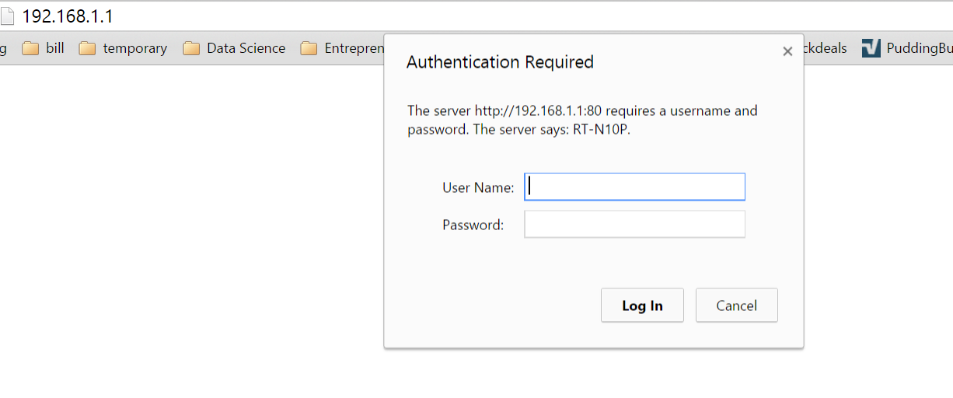

12. In the example of ASUS router, go to WAN, then go to Virtual Server/Port Forwarding.

In the bottom Port Forwarding List, fill the following information, then click Add symbol

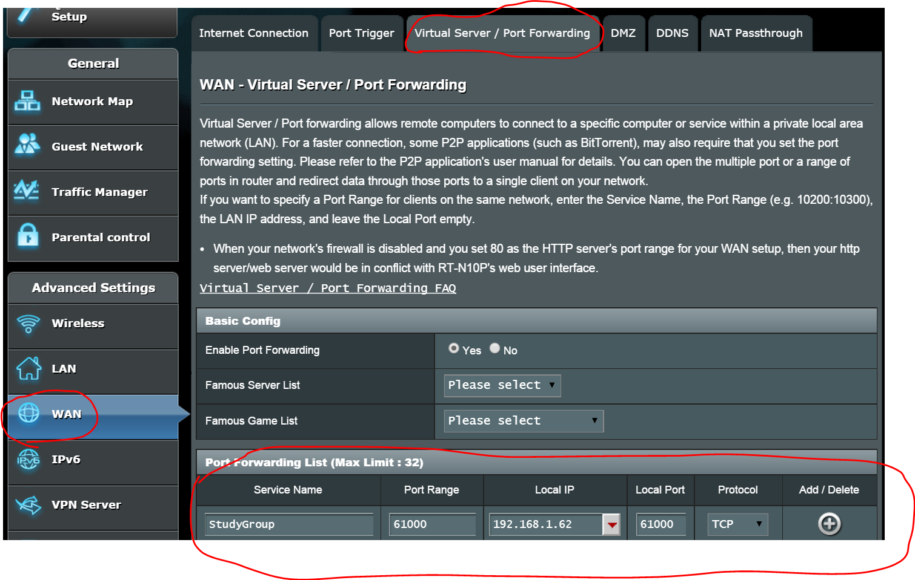

It might several minutes to finish the setting, and internet might be off during the process.

13. Once the port forwarding is set up, we need to find our Public IP address by search what is my IP in google

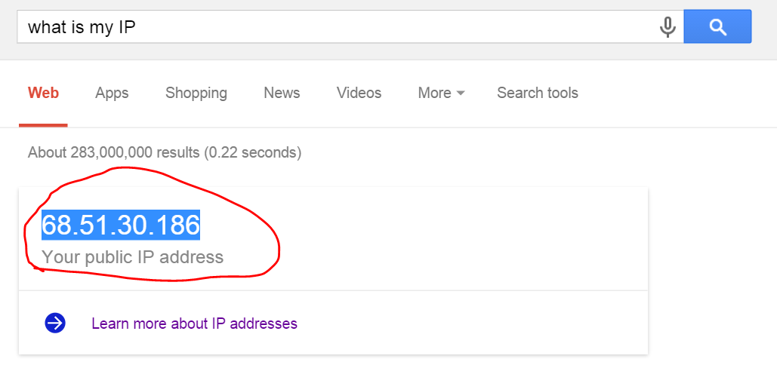

14. Last step ! Type your IP address ending with :8080 in browser, and you should be able to see the web. Share that IP with port address with your friends, and they should be able to see the exact page! Finished.